HIPAA Compliancy Offering
CGHN is excited to announce a partnership with Infinity Network Solutions to provide a discounted HIPAA compliancy program to our membership! This program offering includes a free initial consultation with a Senior Consultant to evaluate your current compliancy posture, and if you choose to implement the I-COMPLY program a discount is applied to the first 3 months of the program.
Infinity Specializes in Healthcare
Infinity has an eighteen-year history of providing services and products to clients in the health care industry. We provide managed IT services, backup and disaster recovery, a HIPAA compliance coach, network security, strategic IT planning and much more. Contact us today to find out what program is right for you.
How Do I Learn More?
To learn more about this program and schedule your initial consultation, please contact Bobbie Jo Gossett at gossett.bobbiejo@cghn.net or call 478-832-6134.

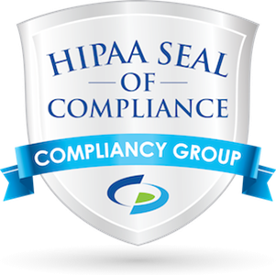

What is I-COMPLY?
Our I-COMPLY program is targeted for any organization that is under the regulatory requirements of HIPAA. This program is designed to assess and identify any GAPS in compliancy and develop a work plan to close those GAPS. Also included is a compliancy coach to assist in policy creation, event documentation, ongoing coaching around rules and regulations of HIPAA, and continuing education.
- Gap Identification
- HIPAA Hotline
- Compliance Documentation
- Contract Management
- Live Compliance Coach Support
- Audit Wizard and Self Audit Questionnaires
- Policy and Procedures Templates
- PHI Use and Disclosure Tracking
- Remediation Manager – Highlights & Resolution Recommendations
- Remediation Manager – Task Assignment and Completion Tracking
- Easy and Comprehensive Compliance Security and Risk Assessment
- Automatic Analysis of Data Collected & Identification of Gaps
- Easy-to-Understand Action Plans for Regulatory Gap Items
- Remediation Plans Based on Scope and Scale of Incident
- Creation of Custom Rules, Gaps and Remediation Plans
- Process for Illustrating Due Diligence by Complete Tracking & Reporting
- Employee Training and Business Associates Tracking
- Auditing and Ongoing Business Associate Tracking, Monitoring and Reporting
- Annual Clean Desk Audits
- Employee Awareness and Education
- Disaster Recovery/Business Continuity Scenario Review

